**Biology: 11. Micro-organisms**

***Please remember to photocopy 4 pages onto one sheet by going A3→A4 and using back to back on the photocopier***

**Syllabus**

**OB65** Investigate the presence of micro-organisms in air and soil

**OB66** State two uses of biotechnology in industry and two uses of biotechnology in medicine

**OB67** List three common illnesses caused by viruses and three caused by bacteria.

**Student Notes**

Microorganisms are very small living things.

There are three types: bacteria, viruses and fungi. We do not need to look at fungi in this chapter.

**Experiment: To investigate the presence of micro-organisms in air and soil**

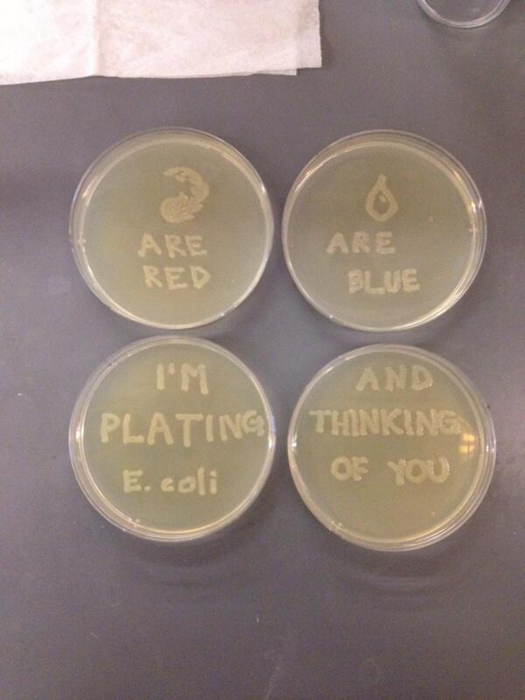

**Equipment**

Petri dishes with sterile nutrient called agar

‘Sterile’ means ‘no contamination’

‘nutrient’ means food

Agar is a jelly-like substance which acts as the food source.

**Procedure**

* Add some soil to one of the petri dishes and leave another sterile as a control.
* Leave both for a few days in a warm environment.

**Observation**

After a few days shiny patches and fluffy growth can be seen in the petri dish which had soil but not in the sterile dish.

Shiny dots correspond to bacterial colonies while fluffy growth corresponds to fungi.

**Did you kwow?**

Sweat itself is odorless. It's the bacteria on the skin that mingles with it and produces body odor!

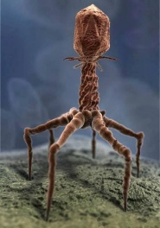**Viruses**

Viruses are the smallest micro-organism that can exist.

**Common illnesses caused by viruses**

The flu (influenza), AIDS, measles, cold sores, the common cold.

On the right is an image of T4 bacteriophage (a virus) via electron microscope

**Bacteria**

Bacteria are simple living cells but are larger than viruses.

**Common illnesses caused by bacteria**

Food poisoning, meningitis, appendicitis, pneumonia, tooth decay.

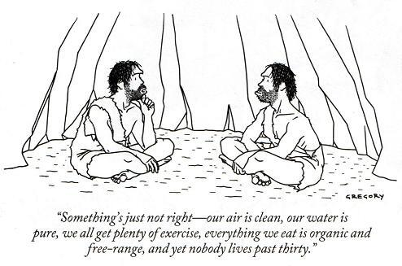

**Biotechnology**

**Biotechnology is the use of living things or parts of living things to make useful products**

**Uses of biotechnology in industry**

1. **Brewing:** Yeast cells get energy by converting sugar into carbon dioxide and alcohol. So the alcohol that we drink is basically yeast poo. Think of that the next time you order a pint with your fake ID.
2. Cheese making
3. Baking
4. Yoghurt
5. Pesticides
6. Genetically modified food
7. Bio-fuel
8. Bacteria to make stain-removing enzymes in washing powders.

**Uses of biotechnology in medicine**

Antibiotics

Hormones (insulin)

Vaccines

**Exam Questions**

1. ****[2008]

The photograph shows Amanita Phalloides, a poisonous fungus, whose common name is ‘Death Cap’. Fungi are decomposers.

Explain the underlined term.

1. [2006] [2006 OL]

Decomposers are living things that release useful materials, from the waste products of plants and animals and from dead plants and animals, for reuse by living organisms. Name two kinds of decomposers found in the soil.

1. [2009]

One petri dish containing agar was left covered. All of the dishes were kept warm for some days and inspected daily.

1. What is the function of the agar?
2. Why was one petri dish left covered?
3. Describe and explain the appearance of the agar in the exposed dishes after some time passed.
4. [2006 OL]
   1. Micro-organisms are used widely in biotechnology. Give one use of biotechnology in industry.
   2. Micro-organisms can be found growing in a variety of locations.

Describe how the presence of micro-organisms in a sample of soil might be investigated.

Include a diagram of any equipment that might be used.

1. [2007]

The photograph shows a stage in the industrial production of cheese.

This is an example of the use of biotechnology in industry.

Give two other examples of the use of biotechnology in industry or medicine.



1. [2010]

The image shown was produced using a scanning electron microscope.

It shows the bacteria Escherichia Coli.

Give one beneficial and one harmful effect of bacteria.

**Exam Solutions**

1. A decomposer is an organism that breaks down dead plants or animals.
2. Bacteria/ fungi/ worms/ maggots/ nematodes/ woodlice/ ants/ protozoa/ springtails/ silver fish/ beetles…
3. To supply nutrients
4. To act as a control
5. Patches appear on the surface indicating that micro-organisms/ bacteria/ fungi are growing
6. Cheese making / brewing / making antibiotics / baking /
7. Equipment: Petri dishes with sterile nutrient agar (medium)

Add some soil to one of the petri dishes and leave another sterile as a control.

Leave both for a few days in a warm environment.

Observation: After a few days bacteria colonies can be seen in the petri dish which had soil but not in the sterile dish.

Shiny dots correspond to bacterial colonies while fluffy growth corresponds to fungi.

1. Bread/ beer/ wine/yoghurt/ antibiotics/ hormones (insulin)/ vaccines/ pesticides/ GM bio-fuels…
2. Beneficial:

Decomposition/ decay/ food/ yoghurt/ vinegar/ cheese/ food supplements/ biotechnology/ insulin/ interferon/ healthy gut/ vaccination/ helps immune system/ antibiotics/ medicine / silage…

Harmful:

Disease/ TB/ pneumonia/ meningitis/ tetanus/ cholera/ anthrax/ food poisoning/ tooth decay/ sore throat/ pimples…

Did you know:

**90 % of our cells are actually bacteria!**

